# APP DEVELOPMENT FOR WASTE MATERIAL COLLECTION FROM MUNICIPALITY

***Project Reference No.: 48S_MSC_0106***

College : GARDEN CITY UNIVERSITY, BENGALURU

Branch : DEPARTMENT OF LIFE SCIENCES

Guide(S) : DR. V. G. SHANMUGA PRIYA, ASSOCIATE PROFESSOR, GCU,

[SHANMUGA.PRIYA@GCU.EDU.IN](mailto:SHANMUGA.PRIYA@GCU.EDU.IN), 9480563489

MS. ELIZABETH.M, ASSISTANT PROFESSOR, GCU,

[ELIZABETH.M@GCU.EDU.IN](mailto:ELIZABETH.M@GCU.EDU.IN), 8105856978

Student(S) : SAKET KUMAR JHA (23MSBI159),

[SAKET.JHA417@GMAIL.COM](mailto:SAKET.JHA417@GMAIL.COM), 7367061357

ARCHANA NS (23MSBI102),

[NSARCHANA58@GMAIL.COM](mailto:NSARCHANA58@GMAIL.COM), 8867377622

KRISHNA NANDANA (23MSBI111),

[KRISHNANANDANA2002@GMAIL.COM](mailto:KRISHNANANDANA2002@GMAIL.COM), 8310415458

GUPTA VINAY CHHOTELAL (23MSIC101),

[GUPTA.VINAYC@GMAIL.COM](mailto:GUPTA.VINAYC@GMAIL.COM) **,** 7738927663

6. Keywords:

****Municipal Solid Waste (MSW) Management, Mobile Application Development, Real-time GPS Tracking, Smart City Solutions, Route Optimization****.

7. Introduction:

In Bengaluru, careless garbage disposal continues to be a pressing issue.  
Studies indicate that nearly 30–40% of waste is improperly discarded.  
This includes dumping on roadsides, near lakes, and on vacant plots.  
Such practices contribute heavily to pollution across the city.  
They also worsen Bengaluru’s already strained waste management system.

A major reason behind this is the lack of real-time coordination.  
Currently, there’s minimal communication between citizens and waste collectors.  
This disconnect leads to missed collections and irresponsible disposal.

To address this gap, a new mobile application has been proposed.  
The app will allow real-time tracking of garbage collection vehicles.  
Citizens can view the live location of these trucks on their phones.  
They'll also see the estimated time of arrival at their doorstep.

This system introduces both predictability and transparency.  
With this knowledge, residents will be more inclined to wait and dispose properly.  
The app will send alerts when a garbage truck is nearby. These timely reminders will prompt residents to act. They reduce the temptation to dump waste in public areas.  
By encouraging better habits, the app aims to build a cleaner Bengaluru. Lakesides, streets, and open plots could finally be free of everyday waste.

8. Objectives:

1. To collect data about the process of waste collection by municipality and waste disposal by common people through survey and from BBMP website.   
2. To develop Web Page for municipality waste collection (Karnataka state), which displays vehicle tracking information, schedules etc.

3. To engage API and develop App (using React Native, Google Maps API, and Firebase will be implemented in the next phase).

4. To provide performance analytics for municipal authorities, integrate traffic and weather data for optimised routes and include a feedback system for service improvement in the App.

**9. Methodology:**

* Analysing the data from the survey and develop strategies to develop the App.
* Frontend Development: Using HTML, CSS, and JavaScript to design interactive, user-friendly interfaces.
* Backend Development: Employing Python or PHP to build robust server-side logic.
* Version Control & Collaboration: Utilizing GitHub for version control and team collaboration.
* Data Management: Managing structured data efficiently using SQL databases.
* API Development: Creating APIs to connect frontend, backend, and third-party services.
* Real-Time Communication: Using Web Sockets or Firebase for instant user updates.
* Testing & Debugging: Continuously testing and fixing issues for a smooth user experience.
* Deployment: Hosting backend on AWS/GCP/Azure with Docker; launching frontend via React Native or Cordova.
* Maintenance & Updates: Adding features, fixing bugs, and optimizing app performance.

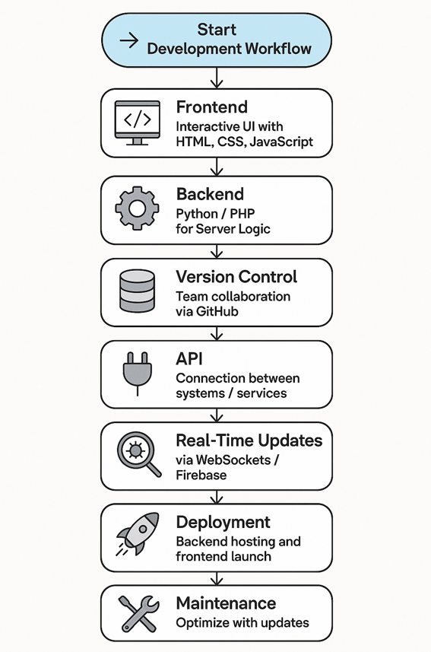

**10. Results & Conclusions:**

A comprehensive survey involving over 100 residents of Bengaluru unveiled critical inefficiencies in the city’s waste management system. Notably, **70%** of participants cited inconsistent garbage collection in their neighborhoods, while **60%** admitted to occasionally resorting to improper disposal methods—primarily due to uncertainty surrounding collection schedules. However, the survey also highlighted a strong public appetite for technological intervention, with **85%** expressing a willingness to adopt a mobile application capable of real-time garbage truck tracking.

To address these challenges, our team engineered a prototype mobile application with a modern, user-centric design. The system architecture integrates a **React Native** front end, a **Python/Flask** backend, and an **SQL** database to ensure scalable, reliable performance. The app delivers a suite of features tailored to enhance civic engagement and operational transparency:

* **Real-time garbage truck tracking** via Google Maps API
* **Push notification alerts** using Firebase for timely updates
* **Integrated feedback mechanism** for user input and reporting
* **Dynamic dashboard** showing area-specific collection schedules

Initial simulations yielded highly encouraging outcomes:

* Notification delivery success rate: **95%**
* Real-time map refresh rate: **~3 seconds delay**
* User satisfaction during testing: **88% rated their experience as 'excellent'**

These results underscore the transformative potential of digital tools in modern urban governance. The prototype not only bridges the information gap between municipal services and residents but also fosters accountability and environmentally responsible behaviors.

Looking ahead, we plan to initiate live pilot testing in select wards across Bengaluru, in collaboration with BBMP and local authorities. The upcoming development roadmap includes:

* **Multilingual interface support** to cater to Bengaluru's diverse population
* **AI-powered route optimization** to improve efficiency and reduce operational delays

11. Project Outcome & Industry Relevance:

The project offers a digitized solution for waste collection scheduling, removing the need for manual planning. By integrating real-time tracking, it ensures collection vehicles follow optimized routes and adhere to accurate timings, reducing delays and operational confusion. Users receive timely notifications, which minimize missed pickups and encourage regular participation. In practical settings, this improves waste management efficiency, leading to cleaner streets and more organized collection systems. The app also promotes environmental consciousness by encouraging waste segregation and recycling habits among citizens, which aligns with modern sustainability goals. Industries such as municipal corporations, smart city planners, and environmental NGOs can implement this solution to enhance their public service infrastructure. Furthermore, it contributes to the field of urban technology by merging software development with civic management. Over time, this can result in reduced costs, better citizen engagement, and a scalable model for other urban egions.

12. Working Model vs. Simulation/Study:

This project involved the development of a functional working model in the form of a mobile/web application. It is not a theoretical study or a simulation, but a practical implementation aimed at solving real-world waste management challenges. The app demonstrates features such as scheduling, tracking, and notification systems, making it a deployable solution for waste collection.

13. Project Outcomes and Learnings:

Yes, the proposed project is highly relevant to society as it directly addresses the growing problem of improper waste disposal, which harms the environment and public health. By providing real-time tracking of garbage collection vehicles, the app makes it easier for people to dispose of their waste responsibly and on time, reducing littering on streets, near lakes, and on vacant plots. This helps create cleaner, healthier surroundings, prevents pollution, and fosters a sense of civic responsibility. Moreover, it raises awareness about waste management, encouraging sustainable habits that benefit the entire community and the environment. The app will be user-friendly and support multiple languages to ensure accessibility and ease of use for a diverse audience.

14. Future Scope:

The current prototype demonstrates strong potential for transforming waste management practices through technology. To build on this foundation, several avenues exist for further enhancement and broader impact:

1. **Geographical Expansion** - Scaling the app to include additional wards within Bengaluru is a natural next step, followed by phased rollouts across other urban centers and eventually into rural areas. Tailoring the platform for different population densities and infrastructure types will be essential for widespread adoption.
2. **Integration of Smart Waste Technologies** - Future iterations of the system could incorporate **IoT-enabled smart bins** that monitor fill levels in real time. These sensors would enable predictive waste collection and reduce unnecessary trips, thereby saving fuel and labor while preventing overflow.
3. **AI-Powered Route Optimization** - Leveraging **machine learning algorithms** to analyze historical and real-time data—such as waste generation patterns, traffic conditions, and bin statuses—can significantly enhance route planning for garbage trucks. This would ensure more efficient resource allocation and reduced operational costs.
4. **Cross-Domain Data Integration** - Incorporating external datasets—such as **weather forecasts, traffic congestion data, and public event schedules**—can refine operational planning. For example, anticipating delays due to rain or road closures could help adjust collection schedules proactively.
5. **Partnerships with Environmental Initiatives** - Collaborations with organizations such as **recycling firms, composting services**, and national initiatives like the **Swachh Bharat Mission** can enrich the app’s impact. Features that guide users in sorting waste or finding local recycling centers could be valuable additions.
6. **Behavioral Insights & Civic Engagement** - Utilizing app-generated data to study user behavior and community response can open new research opportunities in urban policy, sustainability practices, and civic technology. Gamification elements or incentive models may further promote responsible waste disposal habits.
7. **Policy-Level Integration** - Engaging with municipal bodies to integrate the platform into their existing infrastructure can institutionalize its use, helping establish data-driven decision-making in sanitation departments.

